Database System Engineering and Distributed Backend Development
Course Code: 25CS13002E
ROLL NO:2520030177
NAME: P.HARINI
JOINS AND SET OPERATIONS
Query 1: Create the database:
Output:

Query 2: Select the database:

Output:

Query 3: CREATE TABLES:
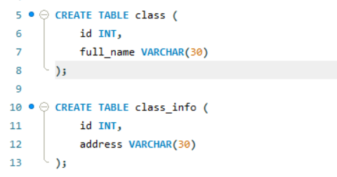

Output:

Query 4: INSERT DATA
Output;

Query 5: CROSS JOIN:
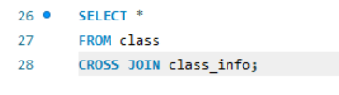
Output:
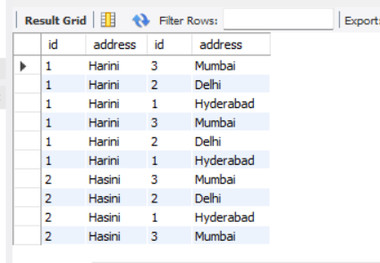

Query 6:
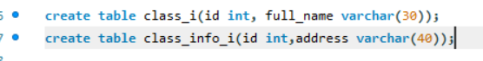
Output:

Query 7:
Output:

Query 8: INNER JOIN
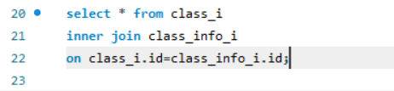
Output:
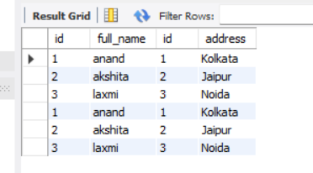

Query 9: INNER JOIN
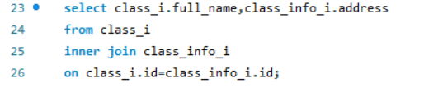
Output:
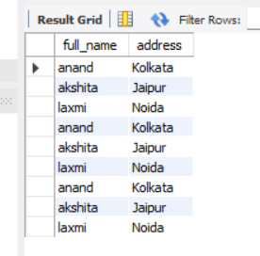

Query 10: NATURAL JOIN
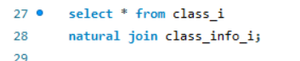
Output:
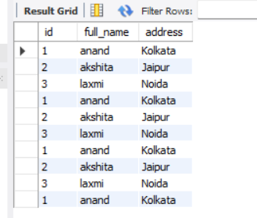

Query 11:
Output:

Query 12: LEFT OUTER JOIN
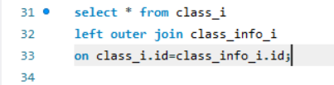

Output:
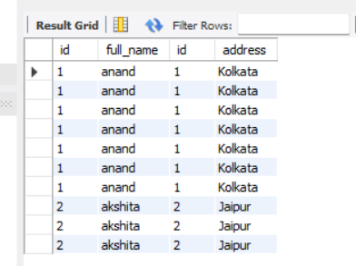

Query 13: LEFT JOIN
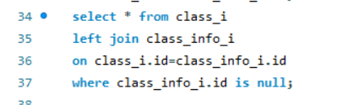
Output:
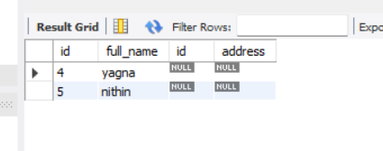

Query 14: RIGHT JOIN
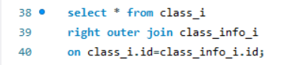

Output:
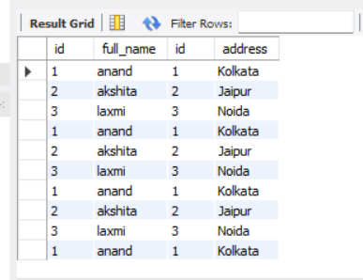

Query 15:RIGHT JOIN
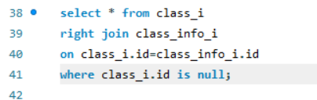
Output:
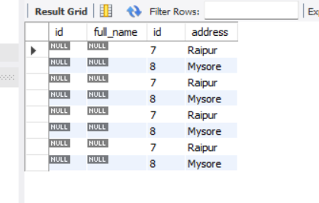

Query 16: FULL OUTER JOIN

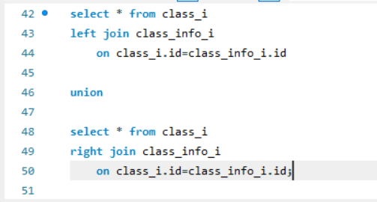
Output:
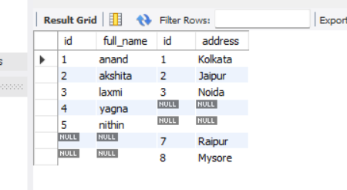

Query 17: FULL OUTER JOIN

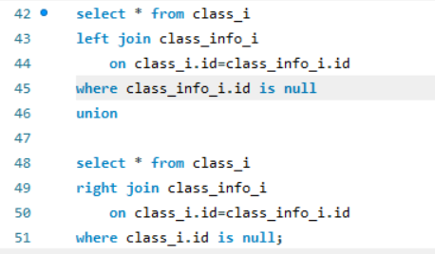

Output:
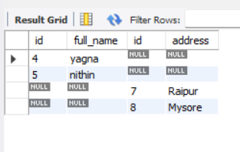

Query 18: UNION
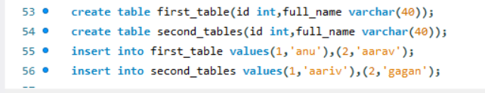
Output:

Query 19: UNION
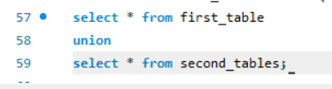
Output:
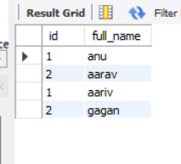

Query 20: UNION
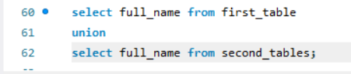
Output:
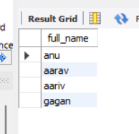

Query 21: UNION ALL
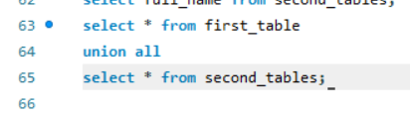

Output:
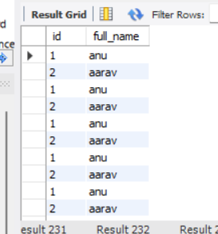

Query 22: UNION ALL
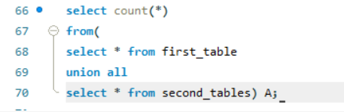
Output:
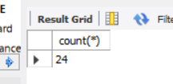

Query 23: INTERSECT
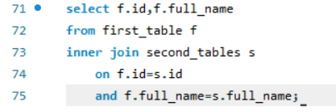

Output:
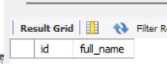

Query 24: INTERSECT
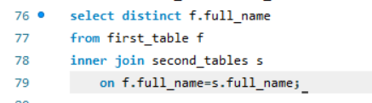
Output:
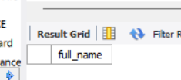

Query 25: MINUS
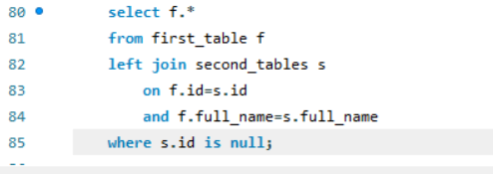
Output:
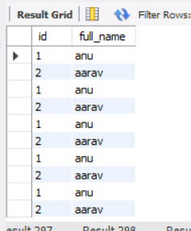

Query 26: MINUS
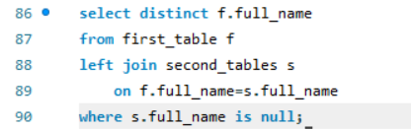
Output:
